Activity 8

1. Write a Python program that will display even numbers from 1 to 50. Use For Loop

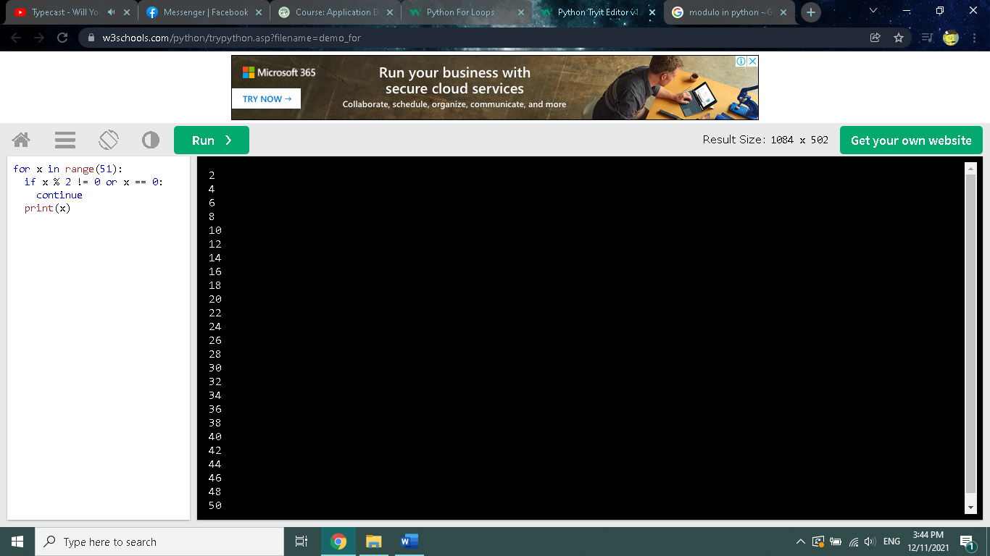

for x in range(51):

if x % 2 != 0 or x == 0:

continue

print(x)